1. list = []
2. n = input()
3. for i in range(0,n): name = input()
4. list =append(name)
5. salary = input()
6. list = append(salary)
7. job.qualification = input()
8. list = append(job.qualification)
9. for i in range(0,n):
10. if(salary[i]<1000 and job.qualification[i] == jobless):
11. Print("Food guarenteed")
12. else:
13. Print("Food not guarenteed")

to supply regular food for the needy people and who are suffering from food scarcity mainly road side people.

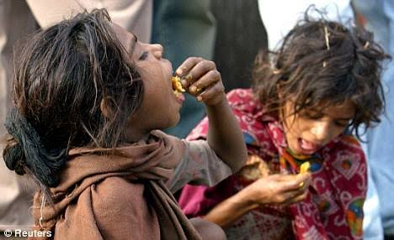

to supply food for the ones who are getting very low salary less than 1000 for 5 months... and to safeguard them from getting died...



in coimbatore many NGOs are doing wonderful job by collecting surplus food from the restaurents and giving it to the poor people so the restaurents can contribute surplus foods to the NGO s.

